GNU Octave, version 3.8.2
Copyright (C) 2014 John W. Eaton and others.
This is free software; see the source code for copying conditions.
There is ABSOLUTELY NO WARRANTY; not even for MERCHANTABILITY or
FITNESS FOR A PARTICULAR PURPOSE. For details, type 'warranty'.

Octave was configured for "x86_64-pc-linux-gnu".

Additional information about Octave is available at http://www.octave.org.

Please contribute if you find this software useful.
For more information, visit http://www.octave.org/get-involved.html

Read http://www.octave.org/bugs.html to learn how to submit bug reports.
For information about changes from previous versions, type 'news'.

a = 1.000000
l = 1.000000
T = 0.100000

ε =
1.0000e-10

n = 10
k = 10
hx = 0.100000
ht = 0.010000

Начальное возмущение =
0.1 * sin(2 * pi * x)

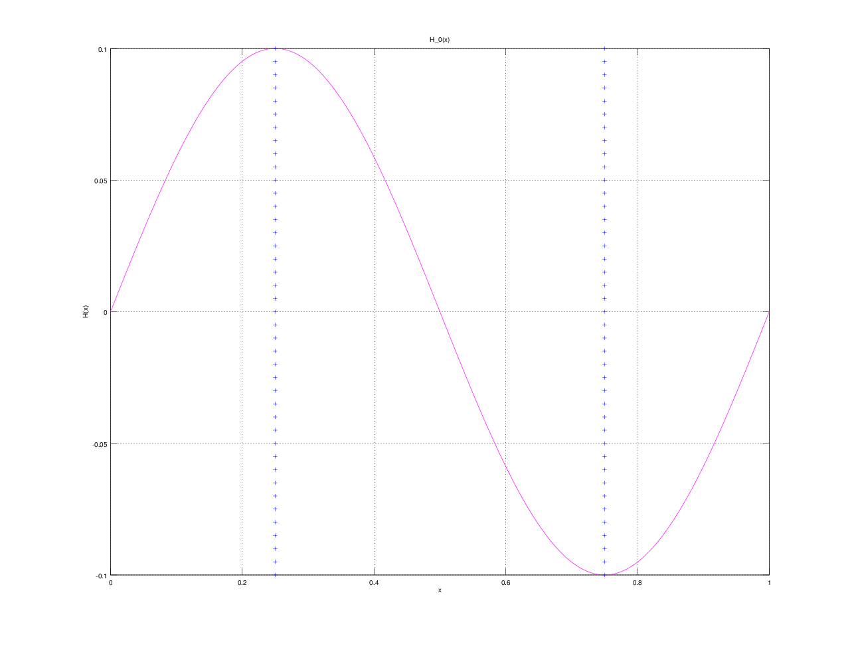

Всего демпферов: 2

Демпфер # 1

x_1 = 0.250000

Верхнее предельное значение w_1(t) =
NaN

Нижнее предельное значение w_1(t) =
NaN

Управляющая функция w_1(t):
0.30917
6.50755
17.14619
21.58044
22.56230
24.29415
20.64715
12.66597
3.76455
-4.26805
-3.27856

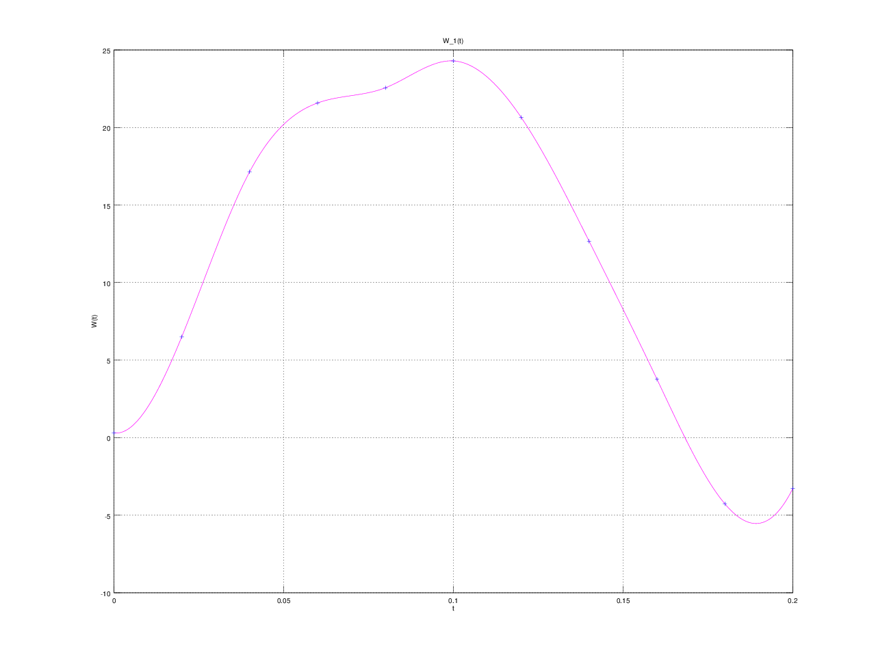

Демпфер # 2

x_2 = 0.750000

Верхнее предельное значение w_2(t) =
NaN

Нижнее предельное значение w_2(t) =
NaN

Управляющая функция w_2(t):
-0.18957
-6.60192
-17.09367
-21.59072
-22.60133
-24.22493
-20.70612
-12.65525
-3.70391
4.10598
3.54361

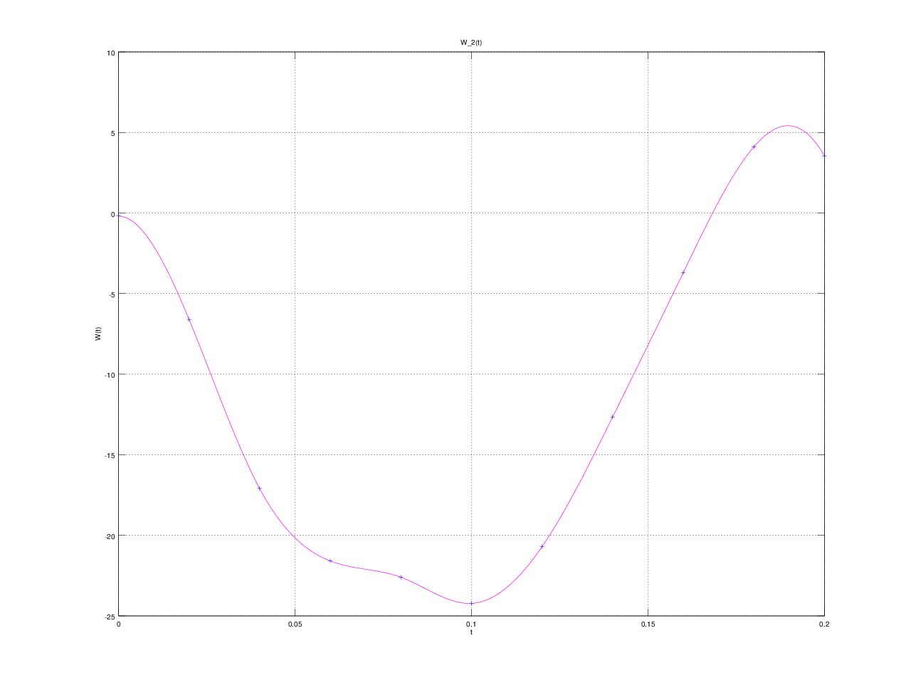

E(T) =
7.2435e-12

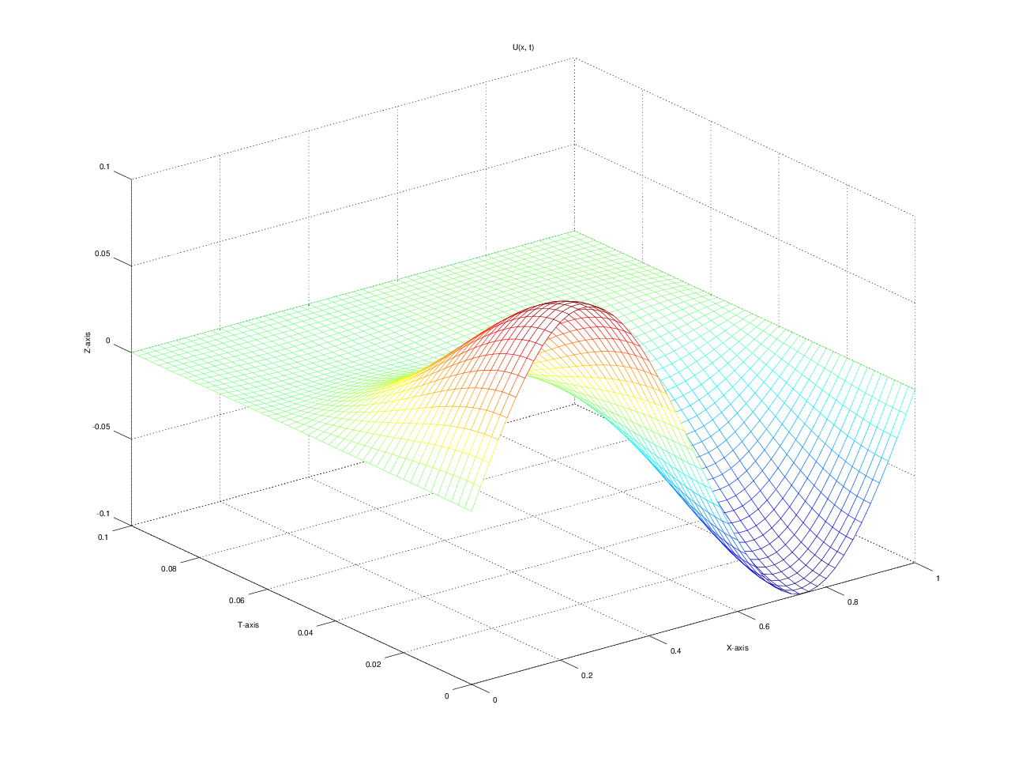

u(x, t)
T = 0.000000: 0.000000 0.058779 0.095106 0.095106 0.058779 0.000000 -0.058779 -0.095106 -0.095106 -0.058779 -0.000000
T = 0.010000: 0.000000 0.054869 0.089094 0.089094 0.054869 0.000000 -0.054868 -0.089091 -0.089091 -0.054868 0.000000
T = 0.020000: 0.000000 0.044586 0.073380 0.073380 0.044586 0.000001 -0.044584 -0.073378 -0.073378 -0.044584 0.000000
T = 0.030000: 0.000000 0.031428 0.052759 0.052759 0.031428 0.000002 -0.031426 -0.052757 -0.052757 -0.031426 0.000000
T = 0.040000: 0.000000 0.018643 0.031740 0.031741 0.018645 0.000002 -0.018641 -0.031739 -0.031740 -0.018643 0.000000
T = 0.050000: 0.000000 0.007948 0.014315 0.014317 0.007950 0.000002 -0.007947 -0.014316 -0.014318 -0.007949 0.000000
T = 0.060000: 0.000000 0.000746 0.003097 0.003097 0.000748 0.000002 -0.000745 -0.003094 -0.003095 -0.000747 0.000000
T = 0.070000: 0.000000 -0.001936 -0.001977 -0.001977 -0.001936 0.000001 0.001939 0.001978 0.001978 0.001938 0.000000
T = 0.080000: 0.000000 -0.001456 -0.002561 -0.002561 -0.001456 0.000001 0.001457 0.002563 0.002564 0.001458 0.000000
T = 0.090000: 0.000000 -0.000458 -0.001056 -0.001056 -0.000458 -0.000000 0.000458 0.001057 0.001058 0.000459 0.000000
T = 0.100000: 0.000000 -0.000000 -0.000000 -0.000000 -0.000000 -0.000001 -0.000000 -0.000000 -0.000000 -0.000000 0.000000

